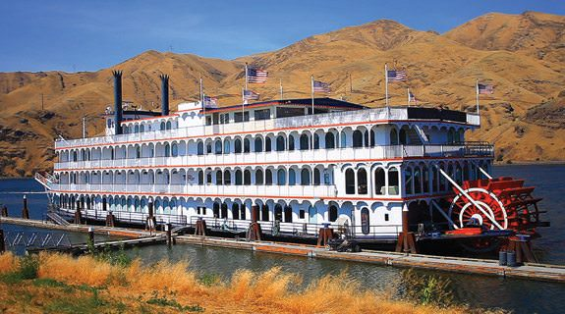 | Spring Fling Trip  June 19-28, 2020  Columbia and Snake River Wine Cruise

Join us as we follow the Lewis and Clark expedition on a special food and wine cruise on the Queen of the West paddle wheeler. Space is limited, so call MayBelle Kern, 806-441-5104, ASAP.

